Green Committee Meeting
Monday, September 8, 2014

Student Members Attending: Brad Patterson, Erin Lynch, Tyler Anderson, Gianluca Nigro, Maddie Collins, Christian Houghton, Sully Quaile, Theo Carr, Max Giarrusso, Michael Chung, Marcus Robertson, Aidan Ryan, Jack Ryan, Griffin Moriarty, Ben Bochman, Cam Baker, Coleman Chase, Jake Dedian, Davis Goode, Michael Saleski, Joe Lindsay, Austin Schilb, Drew Rowland, Tom Noonan, Lea Concannon, Caroline Flibotte, Haley Blasetti, Grace Barrett, Ellie Snow, Hannah O’Laughlin, Colleen Collins, Natalie Gebhart, Kerri Mannion

Others Attending: Mrs. Piantes, Mr. Clune, Janice McPhillips, Mrs. Black, Peter Swanson, Mr. Swanson, Mr. Doerr, Mr. Kane, Ms. Mathews, Ms. Bourassa, Ms. Beaupre, and more who the attendance sheet did not reach

Total: ~45

2 New Positions: Mrs. Roberts is looking for someone to periodically monitor the water levels of Weir River. The monitoring site is located just under the covered bridge on Union Street. Mrs. Roberts is also looking for a volunteer or two to coordinate greenhouse events. They would meet once or twice a month on Friday mornings at 7:30. Speak with Mrs. Roberts if you are interested in this.

Notes from Mrs. Black: We are looking for volunteers to help mentor the middle schoolers as they develop their new Green Club. This would be either after school or via Skype. A student who would be willing to leave school early from their G-Block study would be beneficial.

Bottle Bill: The Bottle Bill is a bill that will be on the ballot in one of the upcoming elections. The bill fights for all beverage bottles to have a 5-cent deposit, as opposed to the 5-cent deposit on limited (only carbonated) beverages now. This would be beneficial to the environment as well as our school, as a lot of money can be made from bottle returns. One study stated that 80% of all beverage containers with a 5-cent deposit get recycled. Davis Goode has volunteered to write up an article about the bill for the Hingham Harborlight and the Hingham Journal. Davis will also try to coordinate some student lobbying (e.g., holding signs, working at phone banks, etc.) to support the ballot initiative. Spread the word – vote yes on article number two!

Marketing at Homecoming: We will be selling “Cuppow!” mason jar lids at homecoming on Saturday the 20th. Brad Patterson and Christian Houghton have volunteered to help Lea with this. We are also looking to get 5 or so volunteers to collect recyclables at Homecoming and other football games. Colleen Collins is going to try and get some from her class.

Climate March: This march for climate change awareness will take place on Sunday, September 21. A bus will be leaving from the Park and Ride near Home Depot in Rockland at 6:30 in the morning. Tickets are $30. World leaders from the UN will be assembling in New York that day, and hopefully we can inspire them to make a change. See Mr. Swanson if you are interested in attending.

Slash the Trash: The Green Committee will be leading the way, monitoring the trash the first Friday of the season. One idea that came up was to guarantee the captains of a team a Green Spot for good team effort (number of participants). Other than that, our system from last year will remain the same.

Green Apple Day of Service: This annual event takes place on Saturday, September 27th. We will be sifting compost and assembling a new raised garden bed in the courtyard. Participants should meet around 9 in the morning that Saturday. This is something that the Middle School’s green team may want to get involved in.

Sneaker Drive: Many students have been saving their sneakers, so another sneaker drive on October 24th is likely. We are looking for some way to return the sneakers. Ideas that came up: Nike’s Re-use a Shoe program, goodwill bins at the Hingham Transfer Station, or send them to Honduras in November with Mr. Peter Swanson. Mr. Swanson will issue a challenge to Whitman-Hanson, our football opponent on Oct. 24th.

Pack the Rack: Pack the Rack is how we encourage students to bike to school by offering fun incentives. We should have Pack the Rack throughout September to October – Pack the Rack Fridays. Possible incentives could include leftover gift cards from last year, a park pass, bike light, or other bike gear. Ms. Beaupre will coordinate this effort.

Bottle Returns: Gianluca Nigro, Davis Goode, Lea Concannon, and Cam Baker have all volunteered to take a term to deposit the schools bottles. If the systems at the other Hingham Schools comply, it would be a good idea to collect theirs as well. On January 10th, Mrs. Black has signed the Green Committee up to process recyclables at the transfer station. Before we do this, we need to complete an act of community service assigned by the DPW in Hingham. Mrs. Black will be getting more information on that.

Bulletin Boards: Lea Concannon, Caroline Flibotte, Haley Blasetti, and Grace Barrett have volunteer to take charge of the Green Committee’s two bulletin boards. The rules of Slash the Trash will be displayed in the Cafeteria – sabotage means disqualification!

Holly Hill Farms: Chipotle will be hosting a fundraiser for Holly Hill Farm’s education department Tuesday the 16th from 5-8pm. Grab dinner with the coupon that was handed out at the end of the meeting, or find it online on the Green Committee’s Facebook group. In order for the proceeds to go to Holly Hill Farms, you must show the coupon at the cash register.

Walk to School Day: This nationwide event is set for Oct. 8th. Is somebody willing to take the lead on promoting this event?

Green Committee’s New Logo: Kerri Mannion has designed a great new logo for the Green Committee! If you would like to make a logo of you own, it would include a red belly turtle, and the name of the club. Be sure to show us at one of the next meetings.
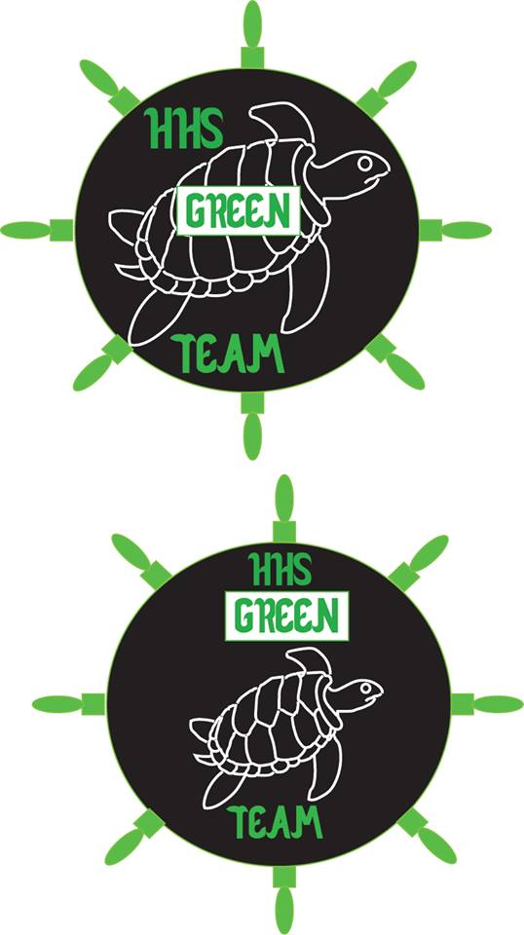
Kerri’s Designs:

